

MT303

OPerations Research

|  |  |
| --- | --- |
| * Murtuza Hussain K17-3886 * M. Hassan Ahmed K17-3654 * Muhammad Faraz K17-3694 * Taneem Ur Rehman K17-3780   Section: GR-3 | Final Project  Topic:  Minimum Spanning Tree |

Teacher: Ms. Asma Masood

Batch: 2017

Semester: Spring 2018

Date: 3/6/2019

Network Models:

In graph theory, a flow network (also known as a transportation network) is a directed graph where each edge has a capacity and each edge receives a flow. The amount of flow on an edge cannot exceed the capacity of the edge. Often in operations research, a directed graph is called a network, the vertices are called nodes and the edges are called arcs. A flow must satisfy the restriction that the amount of flow into a node equals the amount of flow out of it, unless it is a source, which has only outgoing flow, or sink, which has only incoming flow. A network can be used to model traffic in a computer network, circulation with demands, fluids in pipes, currents in an electrical circuit, or anything similar in which something travels through a network of nodes.

Following three algorithms are used for different use cases to solve the network model: -

1. Minimal Spanning Tree
2. Shortest Route Algorithms
3. Maximal Flow Algorithms

# Shortest Route Algorithms:

# Problem Definition:

In graph theory, the shortest path problem is the problem of finding a path between two vertices (or nodes) in a graph such that the sum of the weights of its constituent edges is minimized.

The problem of finding the shortest path between two intersections on a road map may be modeled as a special case of the shortest path problem in graphs, where the vertices correspond to intersections and the edges correspond to road segments, each weighted by the length of the segment.

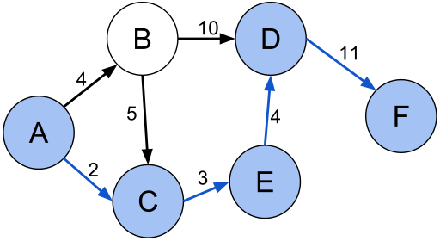

# Solution:

Algorithms for solving Shortest Path Problem:

* Dijkstra’s Algorithm
* Gabow’s Algorithm

# Applications:

* It is used in geographical Maps. To find shortest distance between two points.
* It is used in IP routing to find Open Shortest Path First to send packets through.
* It is used in the telephone network to connect two users with minimal latency.

# Maximal Flow Algorithms:

# Problem Definition:

In optimization theory, maximum flow problems involve finding a feasible flow through a single-source, single-sink flow network that is maximum.

The maximum flow problem can be seen as a special case of more complex network flow problems, such as the circulation problem.

# Solution:

Algorithms for solving Maximal Flow Problem:

* Linear Programming
* Ford–Fulkerson algorithm
* Edmonds–Karp algorithm

# Applications:

* Maximal Flow can be used to find a network rate through which maximum internet bandwidth can be transferred.
* It can be used to design efficient sewer and water plumbing systems.
* To solve Baseball elimination problem that predicts which team will finish with most wins.

# Minimum Spanning Tree:

# Definition:

A minimum spanning tree (MST) is a subset of the edges of a connected, edge-weighted undirected graph that connects all the vertices together, without any cycles and with the minimum possible total edge weight. That is, it is a spanning tree whose sum of edge weights is as small as possible.

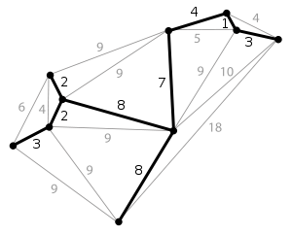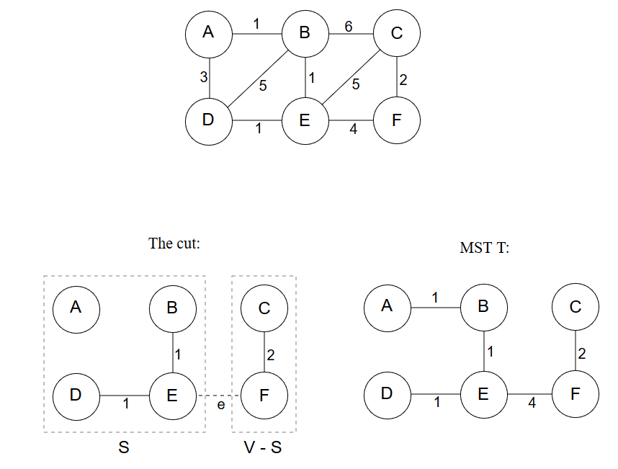

# Solution:

Algorithms for solving Minimum Spanning Tree:

* Kruskals Algorithm
* Prims Algorithm

# Applications:

* Constructing trees for broadcasting in Computer Networks.
* Circuit design for implementing efficient power delivery systems.
* Finding a geographical route for package delivery systems.

Code link For MST: [www.github.com/hassan11196/ORA](http://www.github.com/hassan11196/ORA)

# Minimum Spanning Tree for a Route of Pak tour:

Starting from Karachi

Destinations include: -

* Lahore
* Peshawar
* Swat Valley
* Naran Valley
* Skardu, Gilgit

